Balsawood Bridge

Subject: Civil Engineering  Related Subjects: Mathematics, Science | Grade Level(s): 9-11  Length of Lesson: 2–3 hours | Type: Project  Keywords: Structures, Load-bearing, Bridge Design

Lesson Overview
Students will use math and Science to implement engineering concepts in the design and construction of a model bridge from their own plans that will carry a maximum load while using as little wood as possible; stressing neatness, craftsmanship, and creativity. In this activity, students will use balsawood and Velcro to understand the principles involved and to test various designs. Pictures of different bridges have been provided at the end of this guide.

Lesson Focus
How do civil engineers balance material use, structural strength, and design limitations when building bridges?

Lesson Objective(s) | - Understand the principles of tension, compression, and load distribution in bridge structures.  - Apply engineering design principles to construct a lightweight, high-strength bridge.  - Use measurement and math to stay within strict design parameters.  - Evaluate structural performance through load testing.

Lesson Timing

30 minutes | Introduction, rules, and design planning
75 minutes | Bridge construction
45 minutes | Testing and final discussion

Materials | - Only solid untreated balsawood  - Velcro must be used to attach pieces.
Instructor Prep | - Pre-cut balsa wood into standard stick lengths.  - Prepare individual kits for each team.  - Set up a load-testing station with supports 20 cm apart.  - Create scorecards for recording weight and performance.

Related Resources

Lesson Plan

Introduction
- Discuss how real engineers use limited resources to build strong, functional bridges.
- Introduce key concepts: tension, compression, span, truss, and load distribution.
- Explain all rules clearly. Emphasize roadway access, structure integrity, and Velcro limitations.
- Students sketch bridge ideas on graph paper and get instructor approval before building.

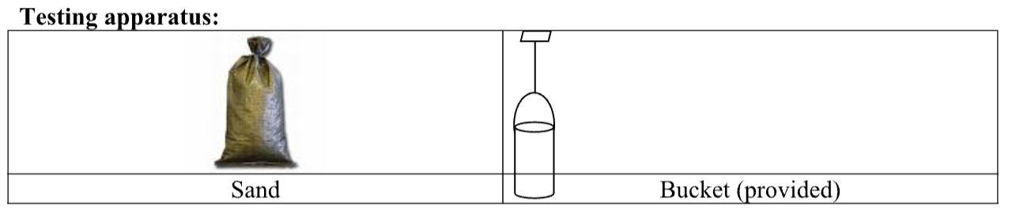

Procedure
Rules for Bridge Size:
- Maximum length 30 cm
- Maximum width 10 cm
- Maximum height 20 cm
- Minimum clearance 10 cm
- Minimum span 20 cm
- Maximum Bridge weight 95 grams

RULES FOR CONSTRUCTION:

- Joints must be at or within ¼” of the end of at least one of the sticks (members).
- No part of a stick may be “Velcroed” to another stick except at the joints of sticks. I.e “Velcroing”is very limited. See Appendix C, “Clarification of Gluing in official rules.”
- No Velcro may extend beyond 3 mm of any joint.
- Members joined at an angle must be at an angle of 30 degrees or more.
- Members may be carved, notched, or cut anywhere along their length.
- Pins and/or gussets are not allowed.
- No material (e.g. paint, varnish, hairspray, etc.) may be applied to the bridge. Ink or a pencil to identify bridge builders, school, and center is ok.
- Maximum allowable weight of completed structure is 95 grams.
- Top of the bridge must support an 8.5 cm x 8.5 cm block which will bear the load for testing.
- Bridge must have supports at least 20 cm apart, and must measure at least 10 cm above a flat surface (an imaginary “river”) at least one point (may be more than one point) between the supports.

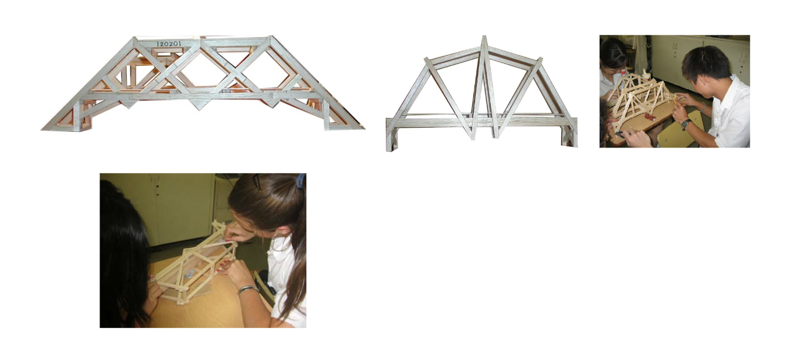

Wrap-up
What worked well in the strongest bridges? How did shape and joint placement affect load performance? What design strategies would you try next time? How do engineers balance efficiency, safety, and cost in the real world?

Lesson Background for Teachers
This challenge simulates the key concerns in bridge construction—design under constraint, structural efficiency, and real-world testing. It promotes engineering thinking, teamwork, and iteration even within a short time frame.

Suggested Real-World STEM Connections
- Civil Engineers design roads, bridges, and transportation systems
- Structural Engineers analyze the stability of infrastructure
- Architectural Engineers merge design with function and safety

Explanation
Bridges experience both compression and tension. Good designs transfer forces along strong paths like triangles. Using less material efficiently is key, just like in professional engineering. The activity encourages experimentation and learning by doing.

Key Concepts and Vocabulary
- Tension – Stretching force
- Compression – Squeezing force
- Span – Distance between supports
- Joint – Point where materials are connected
- Efficiency – Strength relative to weight or material use

Safety Notes
- Supervise use of tools like cutters or small drills
- Ensure load testing area is clear of heads and hands

